**EFFECT OF A COMMON MODE CHOKE (CMC) on RECEIVED NOISE**

**WØLEV 22 January, 2021**

**For those hams who believe a CMC is ‘fluff’, I took some data using the Icom 7300 and my 450-foot long doublet fed with parallel wire transmission line. I turned on the first preamp only to bring the noise on the waterfall up a bit better as I’ve set it to just tickle the bottom on 40-meters with preamps off. In both cases the antenna matching network was adjusted for 1:1 SWR so mismatches do not play into the data. I’m in rural location so local noise is from the multiple SMPSs in the new appliances (2014). Other than that, my noise level is pretty low. Also note that on the Icom 7300, each S-Unit is 3 dB.**

**First, with the CMC in place:**

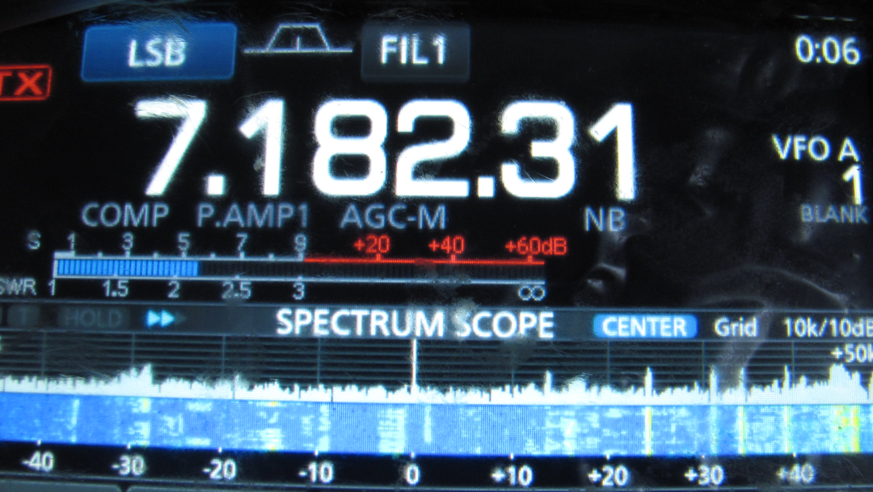

**Note an S-5.5 or -83.5 dBm. Also note the number of signals present on the waterfall.**

**Second, with the CMC removed (and the matching network readjusted for 1:1 SWR):**

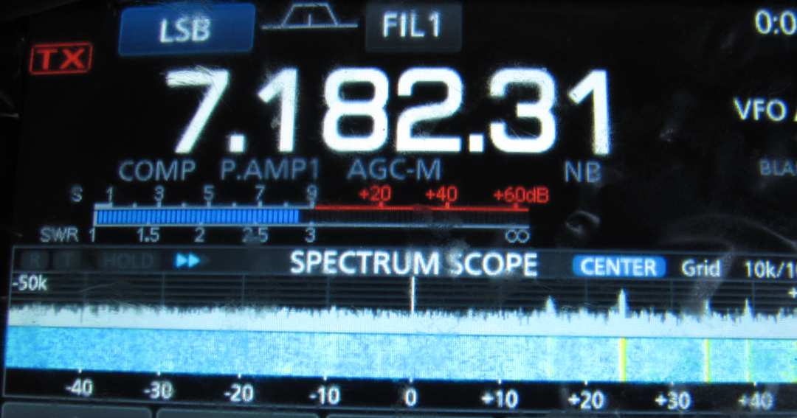

**Note: 1) Higher S-meter reading due to noise: S-8.5 or -71.5 dBm**

**2) Far fewer signals visible on the waterfall. Signals covered**

**by noise.**

**3) Higher noise level indicated on the waterfall.**

**3) Noise is roughly 9 dB greater with no CMC in place.**

**Again, I’m in a very rural location with low antenna noise. Answer the question yourself: Does the CMC do any good at revealing more signals that are otherwise buried in the noise without the choke? I believe you will answer yes.**